HOW TO USE ADVANCED SEARCH IN PIVOT

These instructions are meant to help you get the most inclusive searches, while still having them narrow enough to eliminate most inapplicable opportunities in your search. If you are getting hundreds of items in your search, narrow it by adding other categories.

Find and click on the Advanced Search link on the Pivot Home Page.
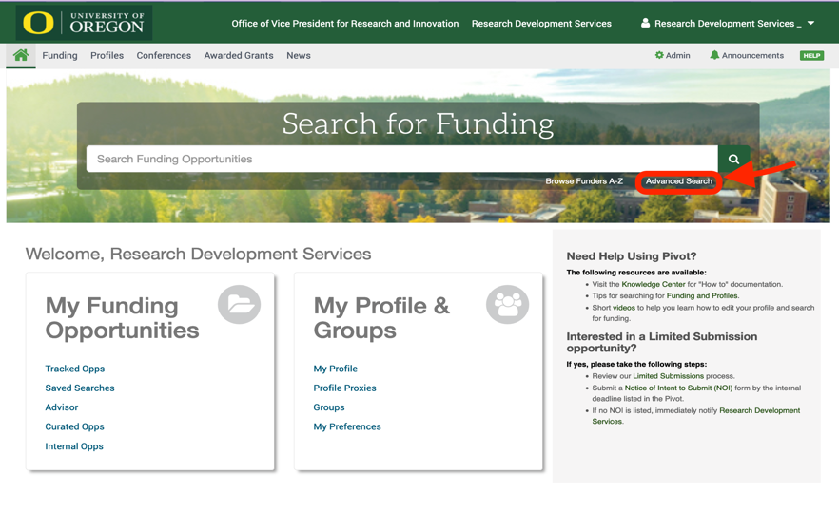

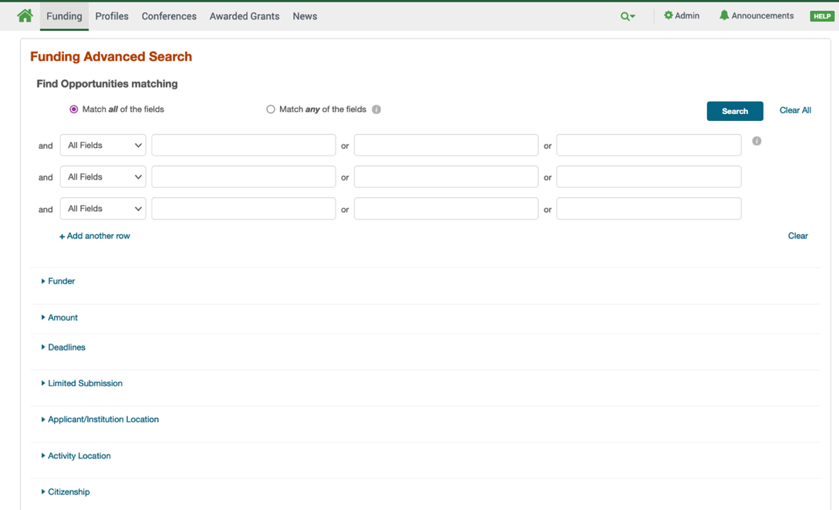
The above action should result in the following Advanced Search page:

IMPORTANT TIPS FOR ADVANCED SEARCH

1) DON’T fill out the following categories:
- Free Text Boxes
- Funder
- Amount
- Limited Submission
- Applicant Type
- Funder Type
- Country of Funder
- Recently Added

2) DO fill out:
a. Applicant/ Institution Location. Type in Oregon. Once added, Pivot will automatically checkmark the boxes for Unrestricted, Sub-entities, and Super-entities.
NOTE: You must deselect Sub-entities if you enter “United States”, or you will get opportunities that are only for institutions in Kansas, New York, Arizona, etc. The same rule applies to other super-entities like Africa or South America.

b. Activity Location. For research done on campus, enter “Oregon”. If research is done elsewhere, select that location. Once added, Pivot will automatically checkmark the boxes for Unrestricted, Sub-entities, and Super-entities (see note above). Also select Unspecified.

c. Citizenship. Because Pivot has many international opportunities, and some funders limit awards based on citizenship, it helps to clarify this in any search. Once added, Pivot will automatically checkmark boxes Unrestricted and Unspecified. Keep these checked.

d. Funding Type. Pivot has a wide range of options (e.g., dissertation funding, visiting personnel) that may not be pertinent to you, so do choose the appropriate criteria for what you are hoping to fund. (e.g., Research: Project Grants and Innovation).

e. Key Word. This is the way Pivot will know how to narrow opportunities to your discipline. You can free type to bring up options. You can also use the Browse function to see each topic “folder”. Click on the tiny triangle to the left to expand the subfolders.
NOTE: Be sure to select the highest level of the folder, along with pertinent subfolders. It is easiest to do this using the Browse feature.
IMPORTANT: Deselect the Explode box, or every single subfolder under the high-level folder will be included.

f. Career Stage. Click all that apply to you. Also include Not Applicable.

g. Excluding Criteria. Go to the bottom of the page (greyed background) to Applicant Type and exclude Commercial or Private Sector, Government or Public Sector, Small Business Only, and any other applicable category.

h. Click Search Button (at the top or bottom right of the page).

Free Text Fields: The open search boxes at the top of the Advanced Search page work differently than the Key Word category. These search the whole body of the funding entry for that particular word. Try the Boolean search when you don’t use Key Words to see if you get different results. Using both separately might give you more viable opportunities that you can track.
Tracked Opportunities. Track individual opportunities to have email updates come to your inbox about changes in its deadline, amount or other elements of the opportunity. To do so, click on the symbol in the upper right of the Funder Profile page.
Saved Searches. Make multiple saved searches with different Funding Types to best fit your needs for external funding. Once you’ve refined your searches as best you can, SAVE them (save link at top of Advanced Search screen). Once a week, Pivot will send you updates of new funding opportunities that fit your saved-search criteria.
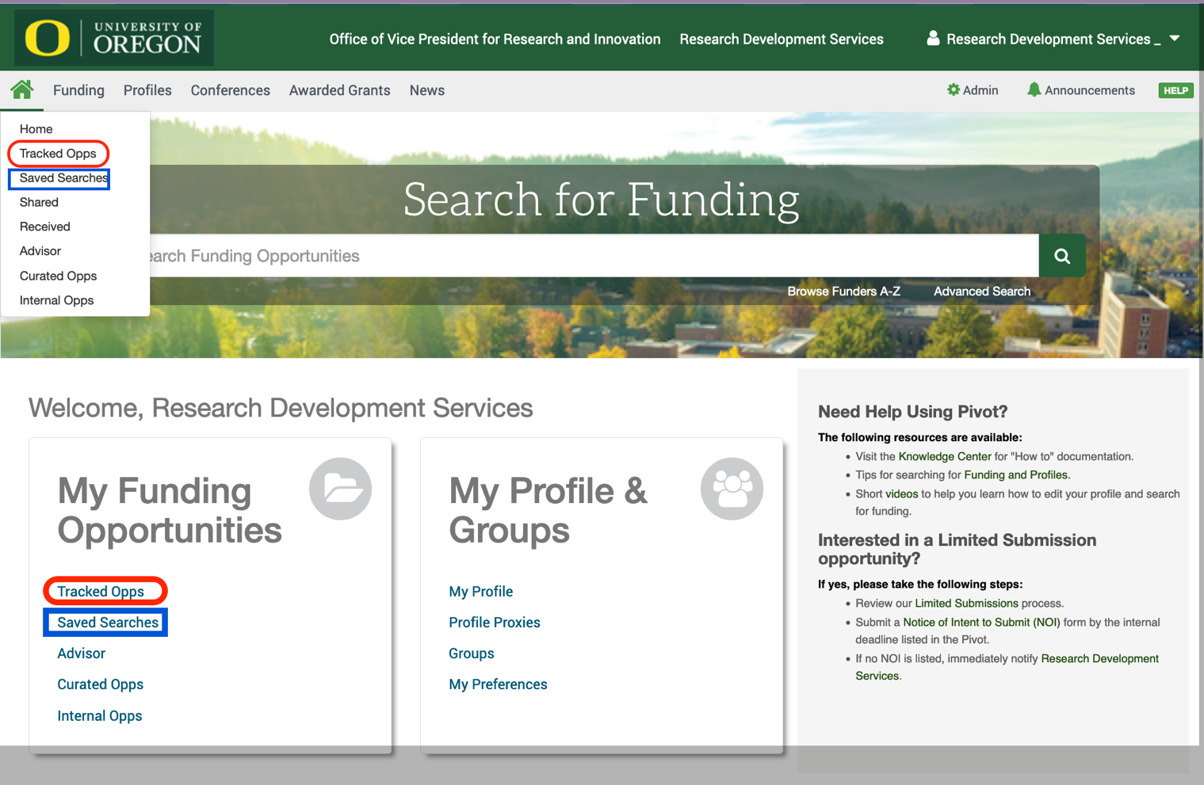
Home Screen. Find your Tracked Opportunities and Saved Searches from the Home Screen. You can always modify them and re-save.

