TeACS Onboarding Checklist

Minimum Training Required Prior to Animal Handling

Animal Occupational Health and Safety Program
- Log on to CITI and complete the course “University of Oregon Occupational Health and Safety for Working with Animals” (New to CITI?).
- Submit the “UO Employee Animal Occupational Health Questionnaire” to the UO Health Center (Animal Occupational Health and Safety Program Info).

Volunteers/unpaid Students Only
- Submit the “Volunteer Service Form” to:
  - IACUC@uoregon.edu and
  - RiskManagement@uoregon.edu

Additional Training in Order to Gain Facility Access

Regulatory Training
- Use your Duck ID to log in at AWS and TeACS. Following the first attempt to log in, we will grant access to the websites.
- Log on to CITI and complete the course “University of Oregon Introduction to Animal Research”.
- Visit the AWS website and review the policies, then complete the quiz.

Facility Specific Training
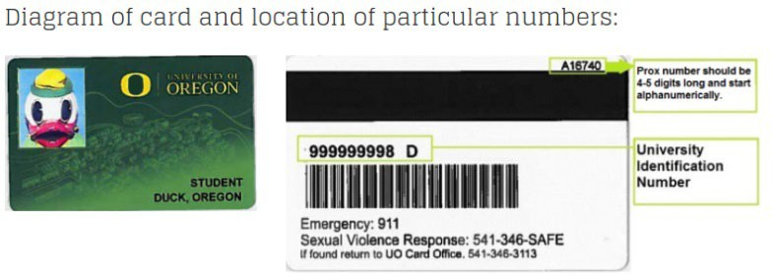
Contact TeACSStaff@uoregon.edu for the following:
- Send the following access info:
  - Name
  - UO ID# (95#)
  - Proximity #
  - Requested 4-digit access PIN
  - Cell Phone Number
  - PI Lab
  - Role (e.g. undergrad, grad student, post doc, lab manager, etc.)
- TeACS policy training
- Facility tour and hands-on animal training
- Skills assessment

Additional Trainings

Lab/Protocol-Specific Training
- Read the protocol you have been added to (How to view protocols in RAP).
- Contact your lab supervisor.

Surgery Training – Only as Requested by your Faculty Member
- Log on to CITI and complete the course “University of Oregon Introduction to Survival Surgery”.
- Contact the Attending Veterinarian, Dr. Kathy Snell for:
  - Hands-on surgical training.
  - Surgical assessment.

