

# Fulbright U.S. Scholar Program: Opportunities for Faculty, Artists, Researchers and Professionals

Jordanna Enrich

Senior Director, Fulbright Student and Scholar Programs

Institute of International Education

# Today’s

**Presentation**

Program Overview Why Fulbright?

Program Overview Why Fulbright Eligibility Eligibility

Types of Awards Application Cycle and Tips Questions Types of Awards Application Cycle and Tips Questions

# Fulbright by the Numbers

The Fulbright Program funds over **8,000 awards** annually:

* 900 US Scholars and Administrators
* 900 Visiting Scholars
* 2,200 US Students
* 4,000 Foreign Students
* 400 Language Teaching Assistants

# MISSION

* In partnership with **160 countries worldwide**, Fulbright offers passionate and accomplished faculty, administrators, artists, journalists, lawyers, and other professionals from all

##### backgrounds an unparalleled opportunity to study, teach, or conduct research.

* Our mission is to **foster mutual understanding** between nations, **advance knowledge** across communities, and improve lives around the world.

# A BRIEF HISTORY

* Established in 1946 by Congress, Fulbright is the United States government’s **flagship international educational and cultural exchange program.**
* Fulbright is **sponsored by the U.S. Department of State** with funding provided by the U.S. Government and administered by the Institute of International Education.

# Diversity, Equity, Inclusion, & Accessibility

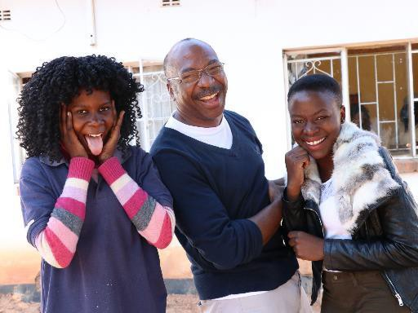The Bureau of Educational and Cultural Affairs (ECA) of the United States Department of State strives to embed diversity, equity, inclusion, and accessibility (DEIA) in all aspects of its work.

Public diplomacy is most effective when people of diverse backgrounds and perspectives participate in people-to-people exchanges and programs to promote mutual understanding. The Bureau incorporates DEIA best practices throughout its exchanges and programs, grants, community partnerships, and in its workforce and workplace.

ECA is committed to addressing barriers based on race, ethnicity, color, national origin, sex, age, disability, sexual orientation, gender identity or expression, religion, geographic location, education, income, socio- economic status, and other diversity dimensions, that may hinder

inclusion in the organization. The Bureau’s commitment to DEIA strengthens U.S. foreign policy and is vital to building trust and partnerships here at home and around the world.

# Photograph of a man taking a picture of a group of children.Fulbright is transformational

* + **Foster relationships** that are real and lasting
  + Expand your **publishing network**
  + Become more **multicultural** in the classroom
  + Serve as an **ambassador** for international

exchange

* + Gain the **professional recognition** as being

identified as a “Fulbright Scholar”

* + Join a vibrant **alumni network**

# photo of a large group of people posed in front of brick buildingsFulbright builds skills and advances careers

* + - 87% Scholars improved **teaching** and

**lecturing** skills

* + - 82% Improved their **research methods**

#### skills

* + - 72% Changed their research **methods**
    - 26% U.S. Scholars assumed a new

**leadership** role

# A group of people posing for the camera in front of a sign reading “Welcome to the Highlands”Fulbright is family-friendly

* + - Approximately **60%** of our awards provide **dependent**

##### support

* + - Many Fulbright dependents go on to have international

careers

# Fulbright is supportive

* + - **65% of applicants** engage with IIE staff
    - **Continued support** while in country from IIE and host

country staff

* + - Access to **Fulbright alumni** as a resource

**U.S. citizenship**

**Degree and experience**, as required by award:

* Ph.D. or other terminal degree

Eligibility for

U.S. Scholar Program

* MA and higher education teaching or professional experience
* Professional and/or artistic experience with

substantial accomplishments

* Teaching experience as required

**Compliance with** [**policies**](https://eca.state.gov/files/bureau/chapter_600_-_3_-_2016_0.pdf)on previous Fulbright Scholar awards: two year waiting period between Fulbright U.S. Scholar award and next application

# A group of women gathered around a desk looking down at a large sheet of paper Award Types:

* + - 1. Scholar Awards
      2. Postdoctoral Awards
      3. Distinguished Scholar Awards
      4. International Education Administrator Awards

#### Man standing in front of a poster written in ArabicFlex Option

* + - Available in 63 countries and all world areas
    - Allows multiple visits over two years

**Fulbright Public Policy Fellowship Global & Regional Awards**

# Selecting the Right Award

* + **Match** country interest, expertise, career profile, and proposal to the award description
  + **Language ability** (if applicable)
  + **Discipline preferences**, when specified
  + **Project relevance** to the host country and/or institution
  + **Benefits** to you and your community

**Remember:** *you can only apply for* ***ONE AWARD per application cycle***

* Teaching
* Research
* Teaching/ Research
* Professional Project

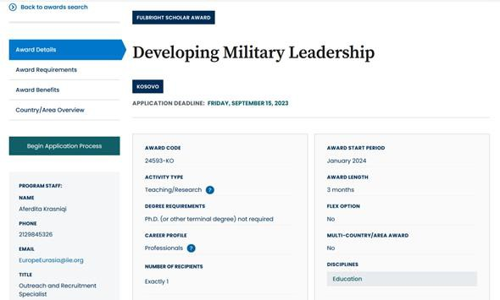

# Understanding the Awards

[Visit](https://awards.cies.org/) [**fulbrightscholars.org**](http://www.fulbrightscholars.org/)[to search awards](https://awards.cies.org/)

[Review important details in:](https://awards.cies.org/)

* [award details](https://awards.cies.org/)
* [award requirements](https://awards.cies.org/)
* [award benefits](https://awards.cies.org/)
* [country/area overview](https://awards.cies.org/)

# Application Components

#### Requirements: Supplemental Materials:

##### Application Form

* + Project **Statement Curriculum Vitae** or Resume

##### 2 Letters of Recommendation

* + **Language Proficiency Report *(if required)***
  + **Letter of Invitation *(if required)***
  + Course outlines or syllabi *(for teaching)*
  + Reference list *(for research)*
  + Portfolio submissions *(for artists,*
  + *architects, and journalists)*

# Tips for a strong application:



READ AWARD’S

DESCRIPTION



**START EARLY**



USE IIE

RESOURCES

Before you start, **read your award’s description carefully** to ensure you meet all requirements and your proposed project is possible.

Start application and enter referees’ information **as soon as possible**.

**Take advantage of IIE resources**, including webinars, office hours and application guidance on our website.

# Application Cycle

* **February**: Competition Opens
* **September 15**: Application Deadline
* **September**: Program staff conduct technical reviews for completeness
* **October to November**: US peer review
* **November to January**: Applicant notified of status. Recommended applications are sent to host countries and the Fulbright Foreign Scholarship Board
* **January to June**: Final decisions are made
* **June onward**: Participants prepare for departure

# Stay Connected with Fulbright

EMAIL us at [scholars@iie.org](mailto:scholars@iie.org)

VISIT [fulbrightscholars.org](http://www.fulbrightscholars.org/) to learn more about the Fulbright U.S. Scholar Program

[REFER your colleagues](https://apply.iie.org/register/refer-a-colleague)