**How to Write a Specific Aims Page for NIH Applicants**

**Overview**

The Specific Aims page is a one-page document that is crucial to the review process for any NIH application. Though this document is geared towards the R01 funding mechanism, it is useful for applicants to the NIH Fellowship and Career Development programs as well.

Notable Aspects of the Specific Aims Page

* IT is the MOST important piece of your grant for peer-review
* Only 2-3 reviewers will have read your full proposal
* Your aims page needs to convince everyone else in the peer-review section
* You will likely edit and refine this document more than any other
* Draft, vet, edit…and repeat!

***

**Steps to Success**

**Step 1: Develop and Refine Your Research Idea**

* Define the research niche you are systematically trying to develop that will move the field forward
* Collect and critically analyze background information
* Generate a preliminary idea that is pertinent to your research problem
* Assess your idea’s potential for success and modify as necessary
* Seek constructive criticism
* Refine idea to maximize potential impact

Pro-tip: Use the HEILMEIER CATECHISM below, first developed for use by the Department of Defense (DOD), to determine if you are ready to submit a proposal.

1. What are you trying to do? Articulate your objectives using absolutely no jargon.
2. How is it done today, and what are the limits of current practice?
3. What is new in your approach and why do you think it will be successful?
4. Who cares? If you are successful, what difference will it make?
5. What are the risks?
6. How much will it cost?
7. How long will it take?
8. What are the mid-term and final “exams” to check for success?

If you can answer these questions, you are in a good position to submit.

Note that the NIH, unlike the DOD, is risk averse. If your idea is high risk, then consider applying to the NIH [R21](https://grants.nih.gov/grants/funding/r21.htm) or [DP2](https://commonfund.nih.gov/newinnovator) mechanisms.

**Step 2: Develop a Proposal Outline**

The next thing you want to do is develop a proposal outline. It is important to scope out your entire project so you can see how your expected outcomes will meet your overall research objective.

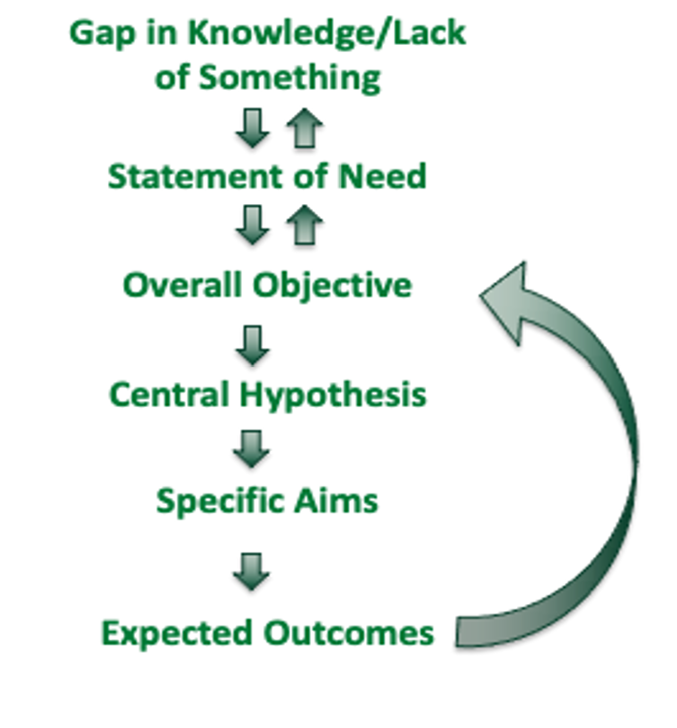

1. Gap in Knowledge/Lack of Something (interrelated with Statement of Need)
2. Statement of Need (interrelated with Overall Objectives)
3. Overall Objective
4. Central Hypothesis
5. Specific Aims
6. Expected Outcomes (which relates back to the overall objective)

All grant proposals start with the gap in knowledge or lack of something. What do we not yet know? Or what do we not yet have that needs to be identified, discovered, or developed in order to move the field forward? For example, if we don't understand how protein X works, we can’t understand disease Y.

This gap informs your statement of need, which in turn shapes the overall objective of your study. Noate that the overall objective should be very specific and directly address the stated need. The overall objective informs your central hypothesis, which should be motivated by your preliminary data. Your proposed research should test your central hypothesis, nothing more, and nothing less.

The specific aims are two to three research objectives designed to test the central hypothesis. If you deliver on your specific aims, you’ll achieve the expected outcomes that support your overall objective.

**Step 3: Develop the Four Paragraphs of a Specific Aims Page**

Note that this guidance is informed by the Grant Writers and Seminar Series Workshop book on writing NIH applications. Examples of different types of specific aims pages are available on the website of the National Institutes for Allergy and Infectious Disease.

**PARAGRAPH 1 - INTRODUCTION**

* Opening Sentence: Capture attention and highlight the NIH-relevant area your application will address; focus on something the reviewers will *not* know
* Current Knowledge: 4-6 sentences to frame why what you propose to do is needed; progression from older knowledge to what currently is the “cutting edge” of the field
* Gap in Knowledge/Lack of Something: Explain the next piece of knowledge that’s necessary to advance the field vertically
* Statement of Need and Consequences of Not Meeting that Need: Frame the gap in knowledge as a problem that demands a solution; what, explicitly, is needed?

**PARAGRAPH 2: WHAT, WHY, WHO**

Go from broadest to narrowest focus in terms of scope

* Long-term goal: establish the continuum of research that you will be pursuing over multiple periods of grant support
* Overall objective: must meet the need you identify in the first paragraph; emphasize the knowledge/discovery/innovation you aspired to provide- not the process that will produce it
* Central Hypothesis and How Formulated: must relate directly to overall objective and your preliminary data
* Rationale: what is possible at the completion of the research that is not possible now; the WHY of this paragraph

**PARAGRAPH 3: SPECIFIC AIMS**

* Aims must test all parts of your central hypothesis
* Aims should flow logically, but not be dependent on each other for their success
* Brief, informative, attention getting “headlines” to convey why that part of the research is being proposed (not what is being done)
* Should be global and open-ended to allow for alternative strategies if necessary (a working hypothesis focuses the aim)

**PARAGRAPH 4: PAY-OFF**

* Expected outcomes of the research
* Generality regarding positive impact (segue into significance section of the proposal)

***

**Specific Aims: Dos and Don’ts**

TYPES OF AIMS

Well-designed Aims:

* + - More than one possible outcome is acceptable
    - Success is not dependent on any single outcome

Unacceptable Aims:

* Only one possible outcome is interesting
* Success of a subsequent aim is dependent on this outcome

Fatally Flawed Aims:

* Descriptive, unfocused, obvious, naïve, or uninterpretable

(Source: American Society of Rheumatology)

**Note that hypothesis-driven research is going to be much more compelling for NIH reviewers.**

EXAMPLES OF AIMS

* Example 1: We will identify [cytokine A] gene polymorphisms in biopsy tissues obtained from a cohort of 20 [disease B] subjects.
* Example 2: We will determine if [cytokine A] plays a critical role in the development of [disease B].
* Example 3: We will compare the roles of [cytokine A] in[disease B and disease C].

The first example states, “We will identify [cytokine A] gene polymorphisms in biopsy tissues obtained from a cohort of 20 [disease B] subjects.” This is descriptive, including the methodological approach, and also an example of a fishing expedition. You are just describing what you are going to do rather than identifying an approach to meet a statement of need. Furthermore, you aim does not need to include your methodology. That comes later.

A slightly better example is, “We will determine if [cytokine A] plays a critical role in the development of [disease B].” While this aim does not include research methods, it is still merely descriptive rather than testing a hypothesis. Furthermore, only one outcome is valuable knowledge.

The third example states “We will compare the roles of [cytokine A] in [disease B and disease C].” This is a comparative model that allows for multiple outcomes that test the hypothesis.

These examples demonstrate how reviewers are going to interpret your language and how you frame your questions. Each of these examples is looking at the same thing. The final one is hypothesis driven, allows for more than one outcome, and is going to be much more compelling to reviewers.

REVIEW YOUR AIMS

* Are my Specific Aims written clearly and easy to understand?
* Would my reviewers see my proposed project as tackling an important problem in a significant field?
* Would they view my Specific Aims as capable of opening up new discoveries in the field?
* Would my reviewers regard the work as new and unique?
* Would they view my Specific Aims as likely to exert a significant influence on the research field(s) involved?

Getting feedback on your specific aims is a very important step before submitting your application. You will want both expert and nonexpert feedback, as well as input from peers outside your field of study. Research Development Services is available to provide feedback that focuses on the key elements of a strong grant narrative--logic, flow, clarity, how well you address the funder’s requirements, and the persuasiveness of your writing.

**\*\*\***

Contact Research Development Services for support on this or any application to fund for your research.