**How to Add the COI Researcher Course in CITI**

1. [Log in to your CITI account](https://www.citiprogram.org/Shibboleth.sso/Login?target=https%3A%2F%2Fwww.citiprogram.org%2FSecure%2FWelcome.cfm%3finst%3d831&amp;entityID=https%3A%2F%2Fshibboleth.uoregon.edu%2Fidp%2Fshibboleth) (link prompts you to enter your Duck ID) and select “My Courses” for your University of Oregon affiliation. Once in that tab, select, “View Courses.”  
     
   Note: you may get a screen between steps 1 and 2 asking you to update your information. If so, complete that update to move to step 2.

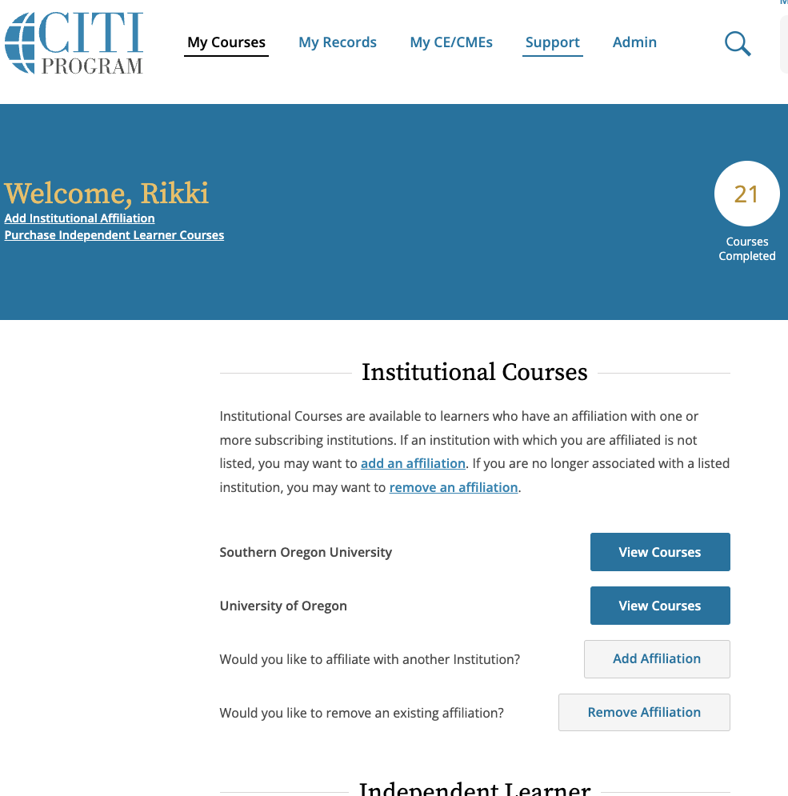

1. Once in the “View Courses” screen, scroll to the bottom to access the “Learner Tools for University of Oregon” menu and select “Add a Course.”

1. This will take you to the “Select Curriculum” page. Check “Conflict of Interest” and select “Next.”

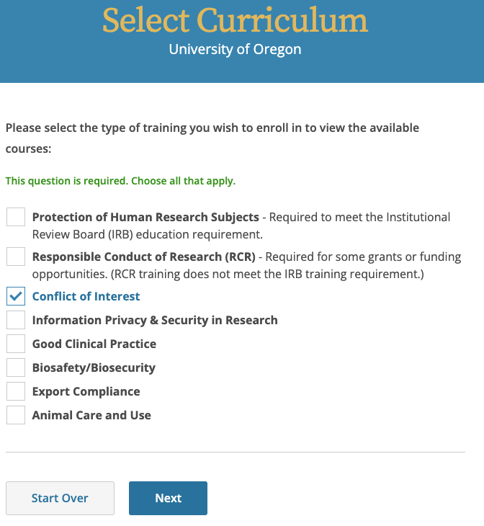

1. Select “COI Researchers” and then “Next.”

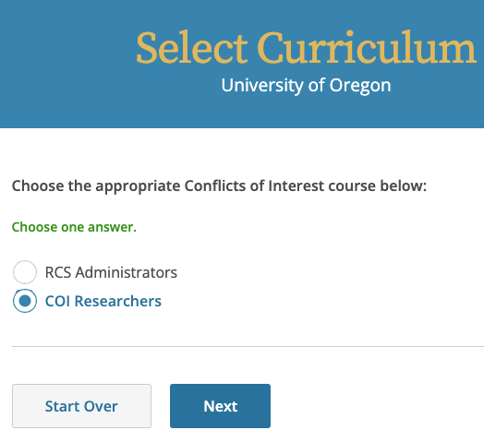

1. You have now added the COI Researcher course to your “My Courses” page. Complete the course at your earliest convenience. Once completed, the course completion date takes two days to migrate into the Research Administration Portal (RAP) Conflict of Interest (COI) module. Once the course completion date migrates into RAP COI, you can complete your disclosure profile in the RAP COI.

Note: Existing researchers can complete their disclosure profile in RAP COI without completing their CITI training first **IF** their previous training date in RAP COI has not already expired.