Accessing a Booked MyTrack Learning Opportunity

A MyTrack Learning Administrator can book a learning opportunity for a specific user. The specific user can then access the booked opportunity using either a link provided in the email invitation or through their MyTrack development library.

Accessing with a Link
Please note: If a learning opportunity is set up as “Administrator managed” and the notification button is selected when the administrator books the learning opportunity, the user will receive the automated email notification from MyTrack. However, the link will not include the “Learn now” button in step 3 that launches the course. The user must instead access the course following the instructions in the Accessing Through a Development Plan section.

- Click on the link provided in the email.
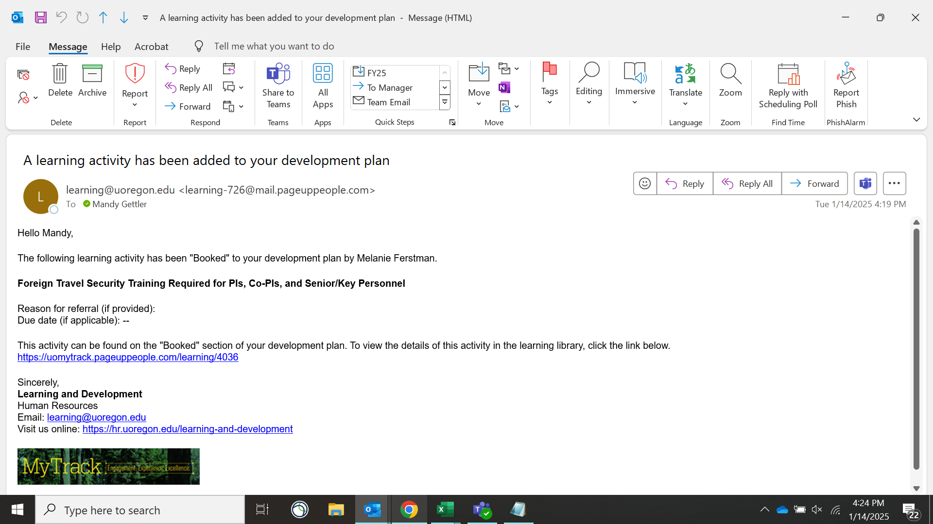

- When prompted, enter your Duck ID.
- Click the “Learn now” button.
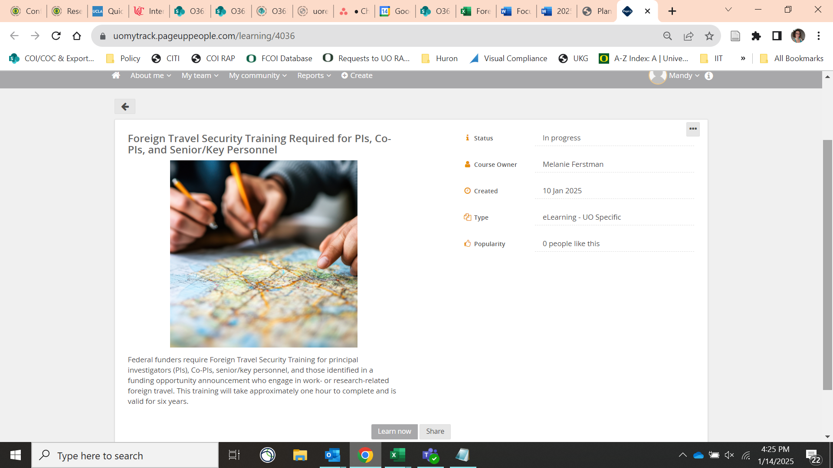

- You may complete the optional fields or leave them blank. Click “Start” to launch the course.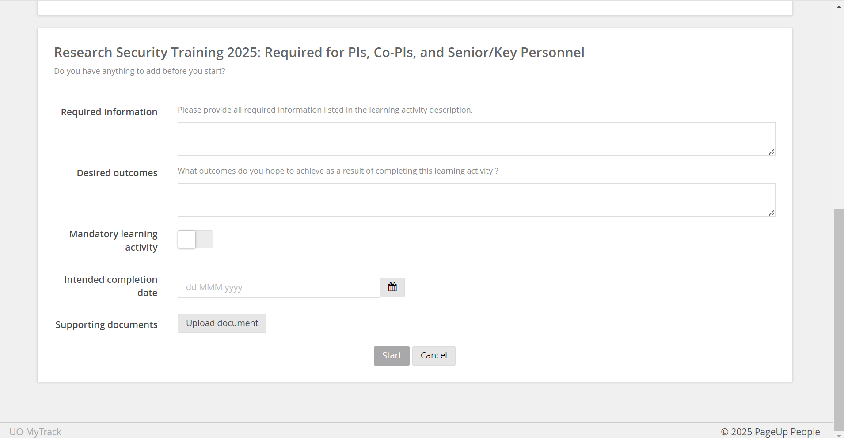

Accessing Through a Development Plan
- Open a web browser and navigate to https://uomytrack.pageuppeople.com/.
- When prompted, enter your Duck ID.
- In the gray menu at the top, select “About me” and then “Development plan.”
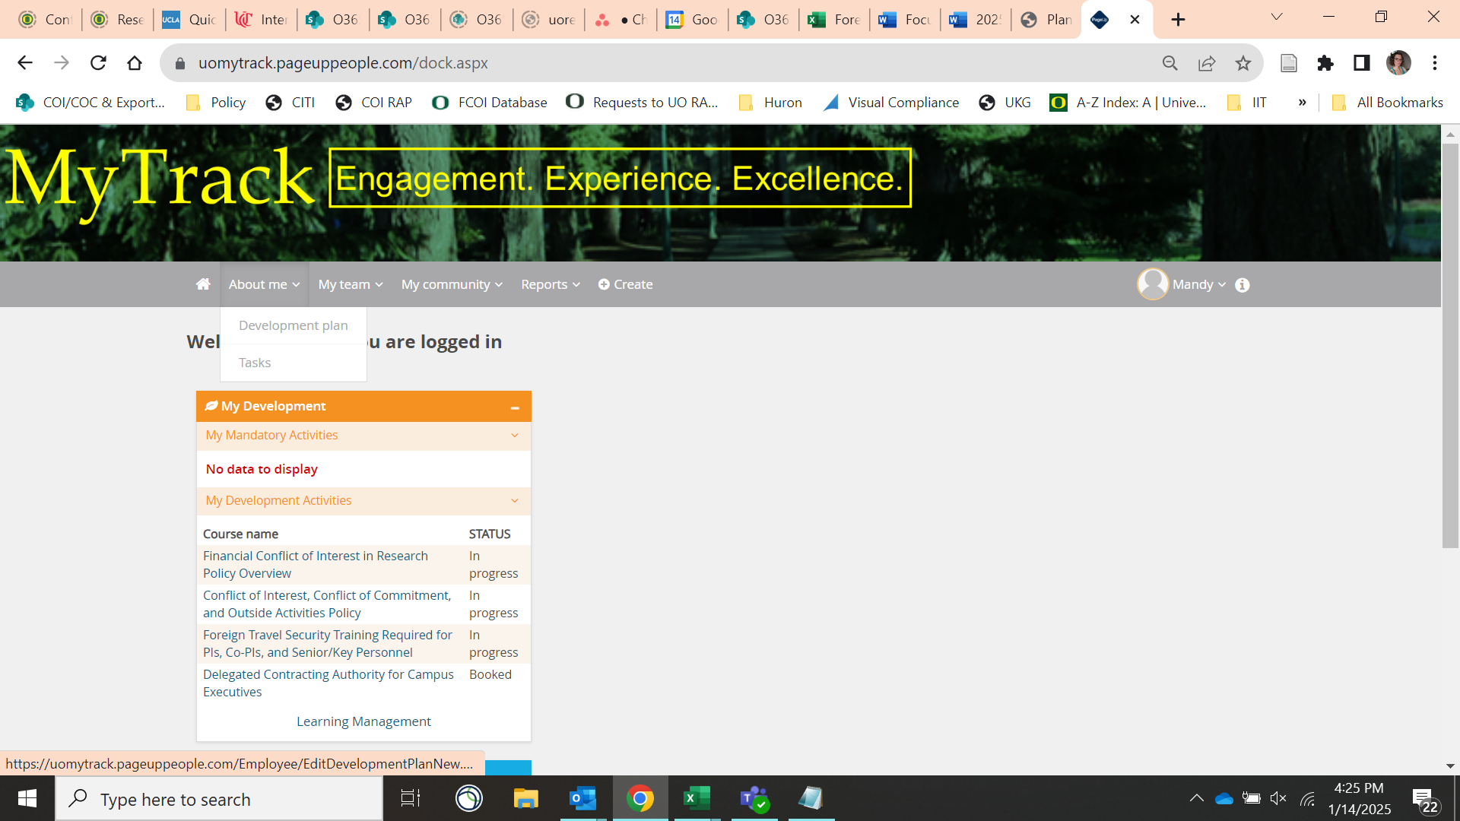

- In the section heading for “booked,” select the course to expand the menu. Then, click the “Learn now” button. The course will be displayed in a new window.
