# Submitting and Updating a COI Disclosure in the the Research Administration Portal

1. After logging into the [Research Administration Portal](https://coi.rap.uoregon.edu/) (RAP) Conflict of Interest (COI) module, select “Dashboard.” Then, in the “My Inbox” tab, click the Disclosure Profile.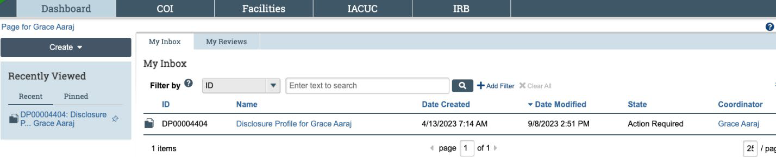
2. You are now in the Disclosure Profile workspace. Click “Edit Disclosure Profile.” A pop-up window will appear.

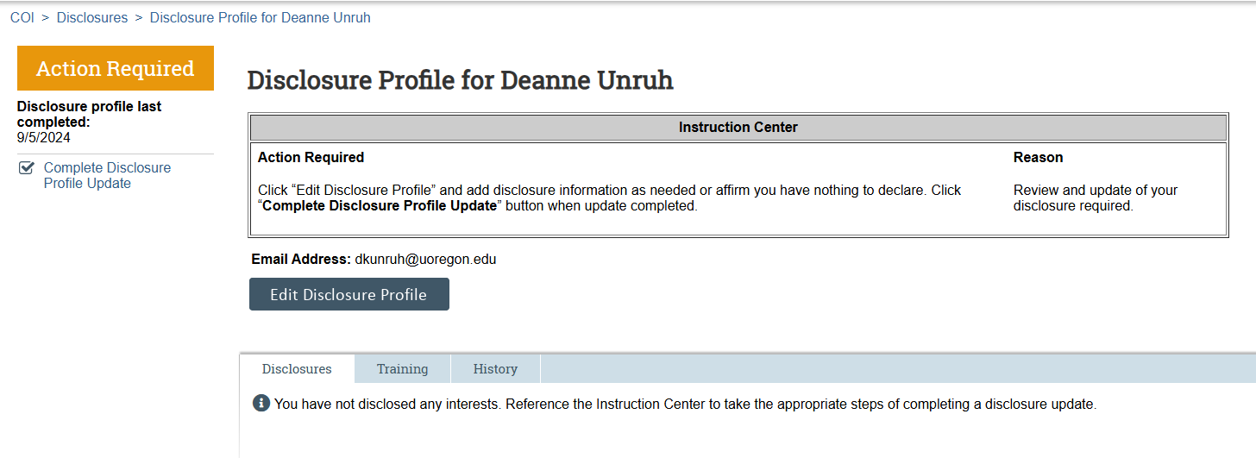

1. Review the instructions and policies. If it’s the first time you’re submitting a disclosure, check the certification box and click “save” before continuing. If you’re updating an existing disclosure, the box may already be checked.

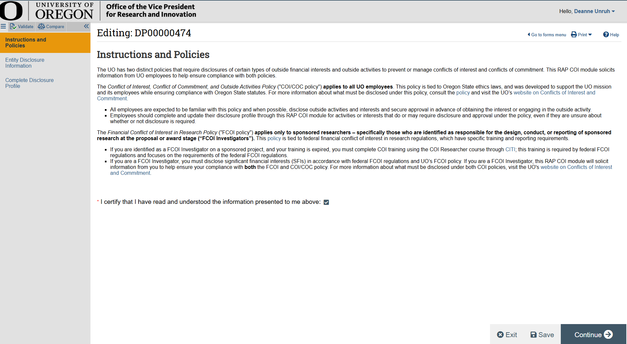

4. Select “Yes” to add an activity or interest to your disclosure. If you have no activity or interest to disclose, select “No,” then skip to step 9.

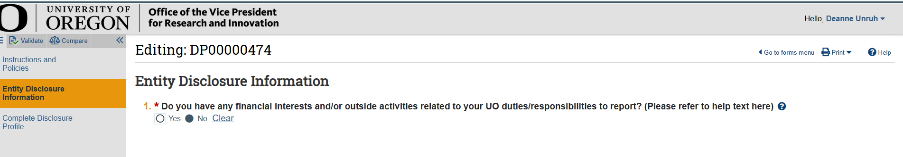

5. Once yes is selected, select the “+Add” button on the left side of the screen.

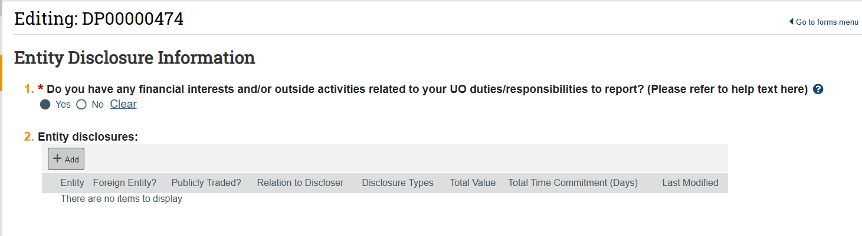

6. A panel will open on your screen. Search for the entity under question one. If you cannot find it, select the ellipses (…) below the search bar.

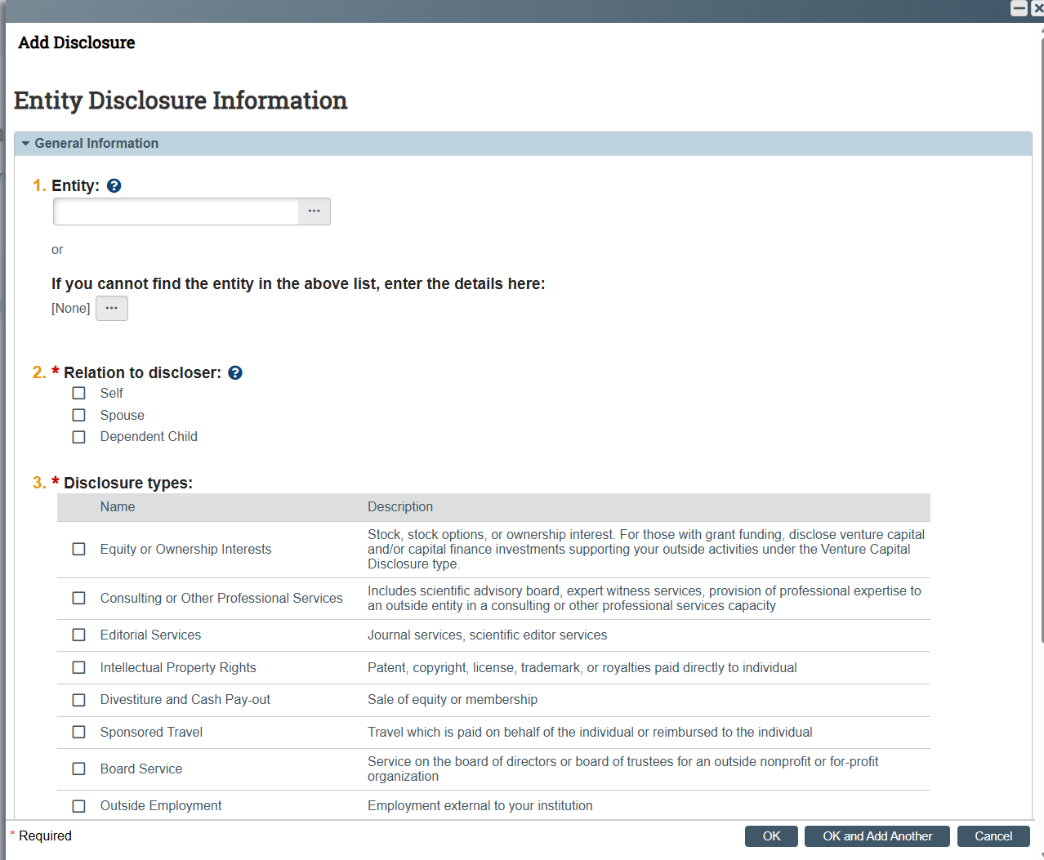

7. Select the checkbox(es) to indicate whether this activity is associated with you, your spouse, or dependent child. If this activity or interest is related to someone else, select any box to move forward. There will be a text box where you can share additional information later.

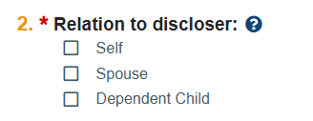

8. Select each box that applies to your interest or activity with the entity you selected during step 6. Each checkbox will display questions specific to your interest or activity. Click “OK” when you’ve finished entering information.

Only responses with a red asterisk are required, but users are encouraged to provide as much information as possible, so the Conflict-of-Interest Office does not need to request additional information. If you have any questions or concerns about the information being requested, contact [coi@uoregon.edu](mailto:coi@uoregon.edu).

**NEW:** Effective October 10, 2025, if you receive funding from the National Science Foundation (NSF) or the U.S. Department of Agriculture (USDA) *and* you have added an activity or financial interest with a foreign entity that is included in your biographical sketch and/or current/pending support document, you **must** upload a copy of the agreement in the related documents question. NSF and USDA require the UO to review agreements with foreign entities to be sure they do not conflict with award terms and conditions and to retain copies of those agreements. Examples include, but are not limited to, courtesy appointment contracts or appointment emails, employment contracts, stock purchase agreements, shareholder agreements, and equity incentive plans.

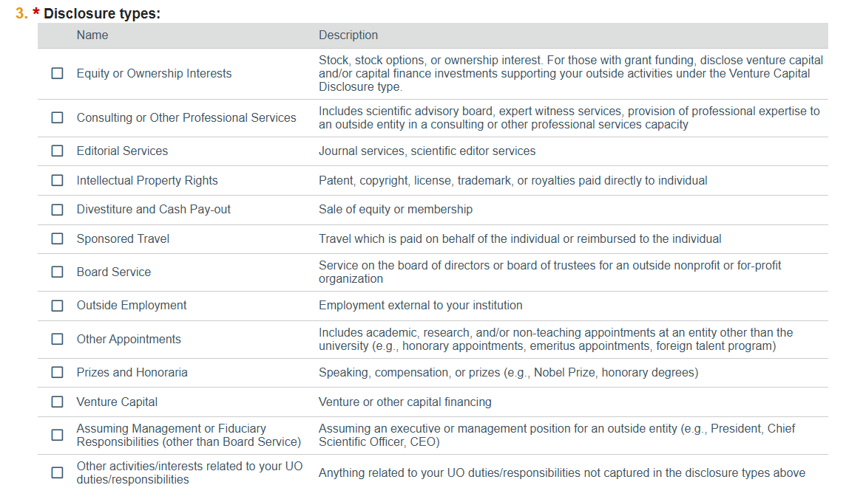

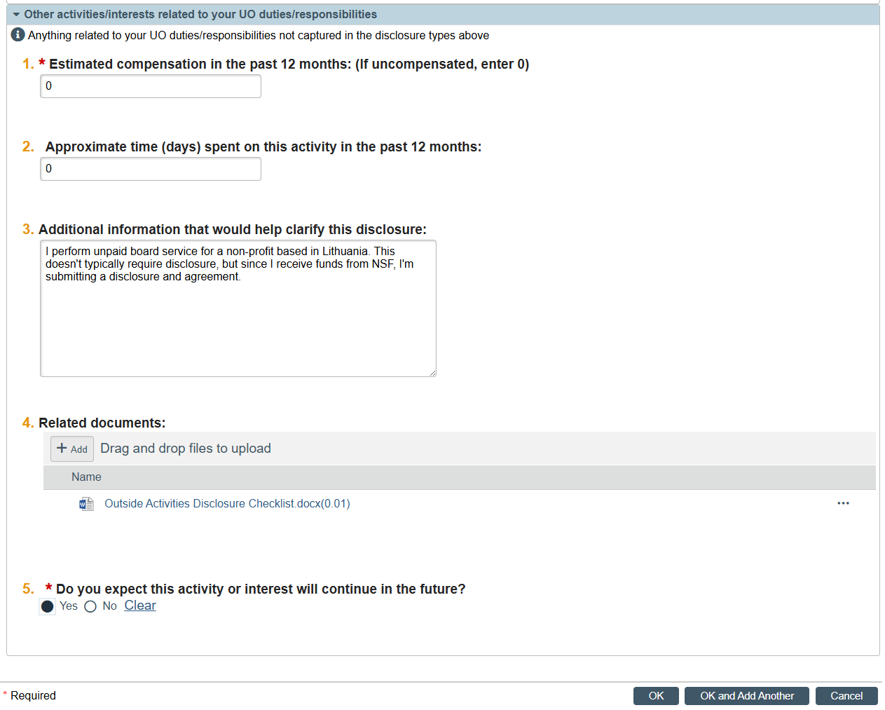

9. After you have entered all relevant information, select “OK.” The panel will close, and you will see a summary of the disclosure appear. Click “Save”. If you are done adding interests and/or activities, click “Continue” on the bottom right of the screen. If you have additional interests to add, return to step 5 and repeat as necessary.

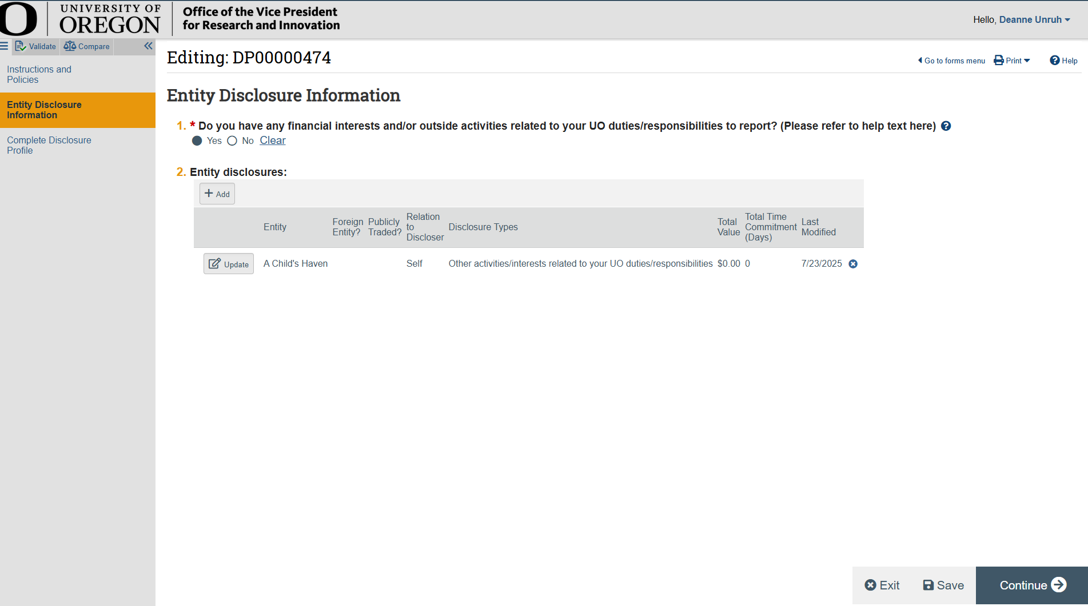

10. **IMPORTANT**: To submit your disclosure profile, select “Complete Disclosure Profile Update” at the center of the screen. Selecting “finish” or “save” will not submit your disclosure to the Conflict-of-Interest Office.

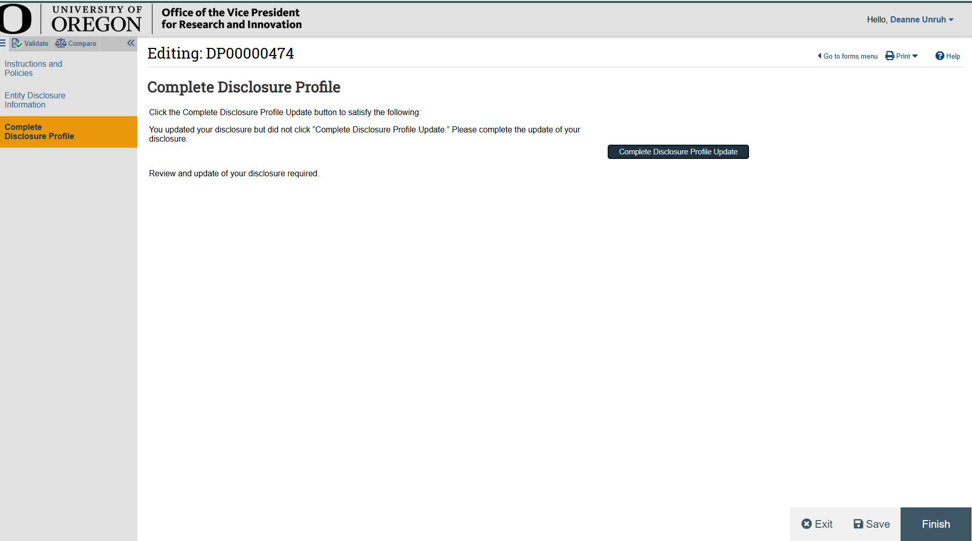

11. A pop up window will appear. Review the affirmation and select “OK” to agree. If you’re unable to agree, please contact [coi@uoregon.edu](mailto:coi@uoregon.edu).

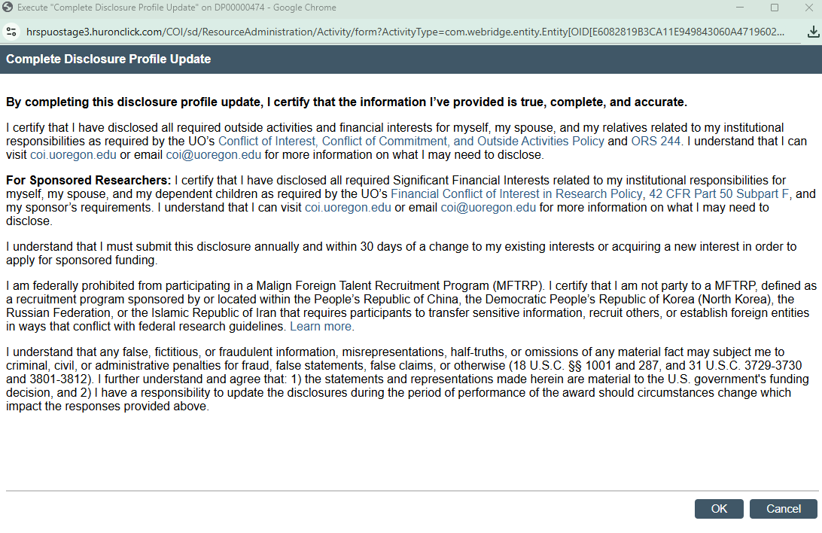

12. Your profile will now display “No Action Required” and you will receive an email confirming that your profile was successfully submitted. Conflict-of-Interest staff will review your profile within 3 business days and request additional information if necessary.

Thank you for your attention to this important compliance requirement!

