Facilities and Other Resources

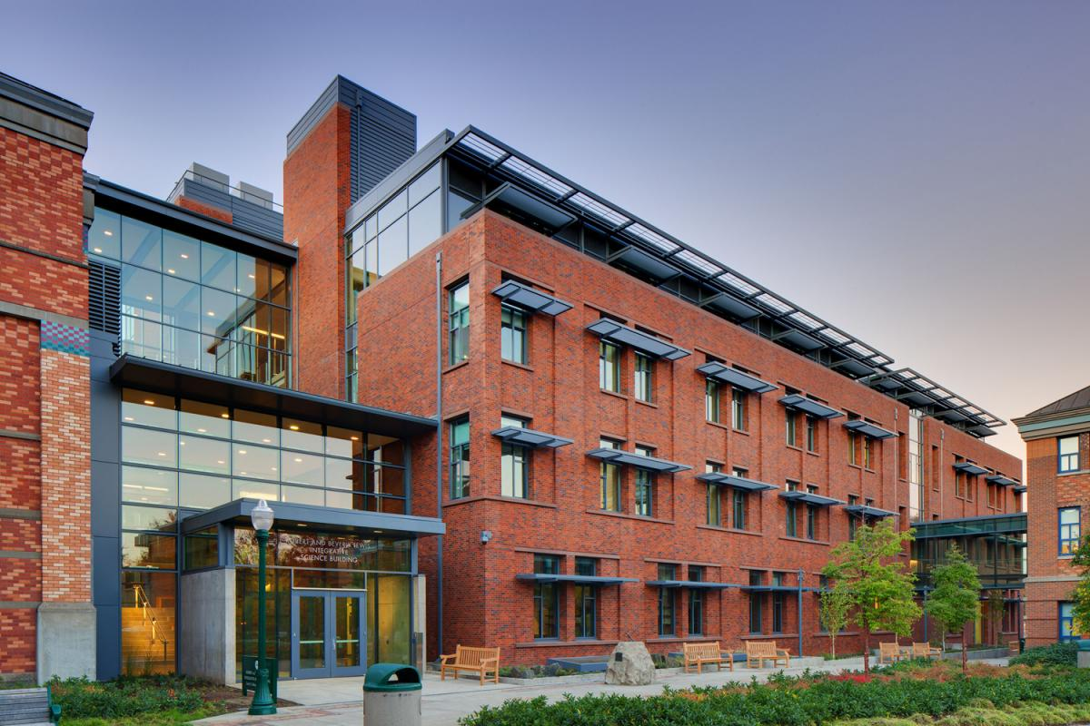
UO Resources and Facilities

Lewis Integrative Science Building (LISB)
The LISB is a new LEED platinum certified state of the art building opened in 2012 that contains multi-disciplinary researchers from three different departments. It also houses the Lewis Center for Neuroimaging (LCNI) and Animal Care Services (ACS) core research facilities used in this application, and several core facilities not used here.

Laboratory
The LISB houses the LCNI research core facilities as well as individual lab laboratory space for XXXXXX. It is where the proposed project will be housed.
There is more than 30,000 sqft of laboratory space, shared between faculty to promote interaction between multi-disciplinary researchers.

Clinical
There are a number of interview/testing rooms for behavioral experiments and several EEG booths uniquely shielded for noise shared between investigators.

Animal
The LISB houses a large animal facility on the first floor, with direct indoor access to the LCNI, although no animal MRI is proposed at the UO in this application.

Computing
The LISB has two primary clusters for computation, the LCNI server and the RACS server, as well as a host of desktop solutions for access to the main compute servers. See more info below.

Office
The LISB contains office space for 46 multi-disciplinary faculty from Psychology, Biology, Chemistry, Neuroscience, and Physiology and is directly connected to other buildings as part of the Lokey Science Complex, allowing interaction with investigators across other a range of disciplines.

Lewis Center for Neuroimaging (LCNI)
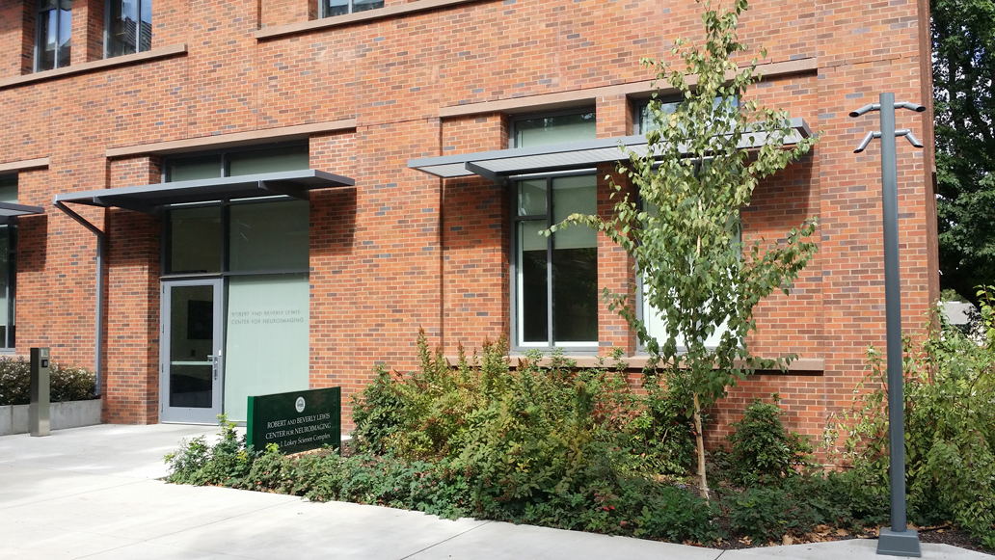
The LCNI is a core-research facility under the auspices of the Office of the Vice President of Research and Innovation designed to enhance access to state-of-the art MRI-related research to the UO faculty and surrounding research community. The center, with its own private entrance (see figure below) is housed in the LISB and contains a Siemens Skyra 3-Tesla MRI machine dedicated to research. A generous endowment by the Lewis family provides unparalleled infrastructure support for staff and equipment dedicated to center activity. The center has five full-time staff, including a director, MRI radiology technologist, MR physicist, and administrative staff. The technologist has extensive experience with scanning children and adolescents in clinical and research settings.
The center is also steps away from Straub Hall and the Prevention Science Institute at the riverfront research park.

Laboratory
The centerpiece of the LCNI is the Siemens Skyra 3T MRI machine. This magnet is approximately 6 years old and has been upgraded with both Product and WIP multi-band sequences, including multi-echo options for multiband. We have a number of coils from Siemens and custom built, including a Siemens 32-channel head coil with optimized sequences based on the latest Human Connectome Project’s published work. We support both Mac and PC presentation with both goggle and projector systems with 5-fingered response boxes for both hands. With a large magnet room and control room ideal for research training, our lab is ideal for the type of cross-disciplinary work proposed in this application.
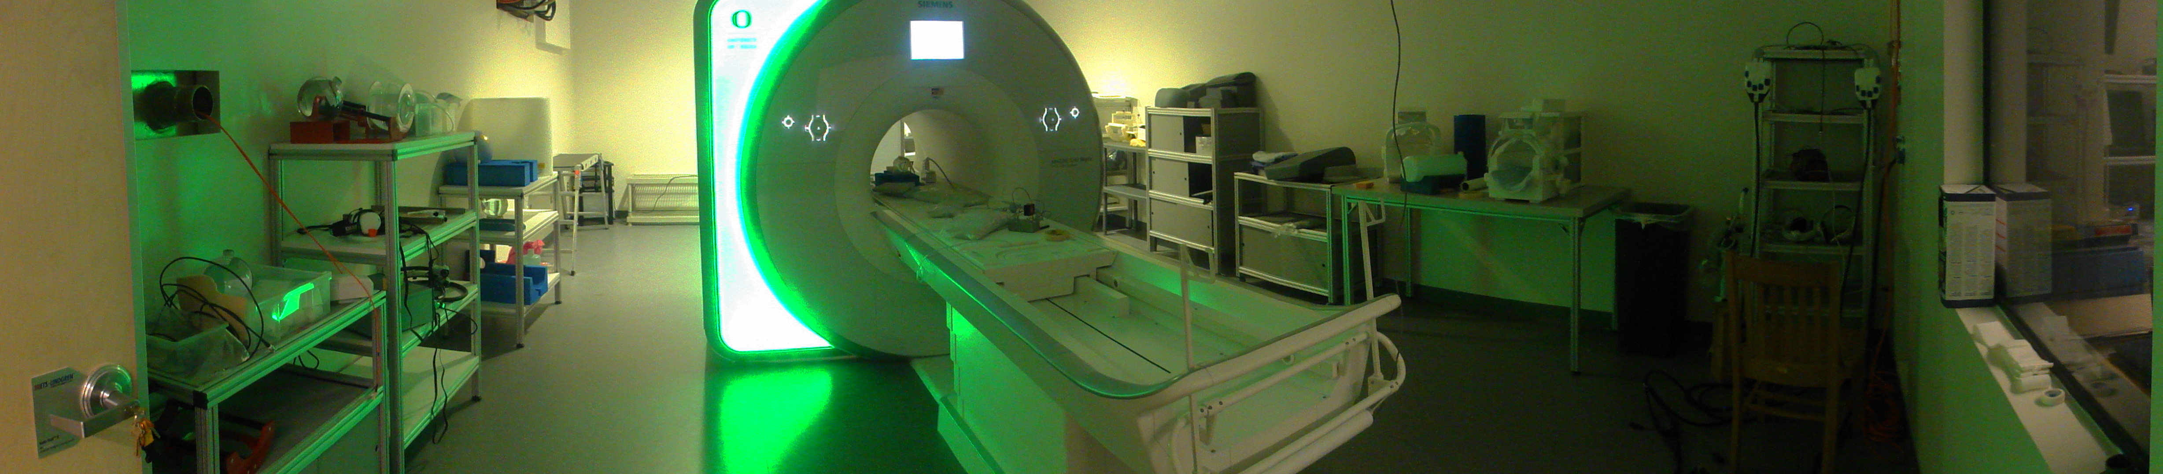
The LCNI also has a large electronics laboratory for coil design and hardware construction and directly adjacent to the console room, a separate room contains a MR-simulator used to acclimate participants to the MR-environment with moveable participant table, full visual/audio presentation and response measurement capabilities, and accurate auditory simulation of EPI sequences.

Clinical
The LCNI has space for private physical exams, pre-testing, and interviews across the hall from the magnet room, equipped with interview table, chairs, and computer for pre-testing.

Animal
The LCNI is well-positioned for animal research, starting with its location, adjacent to the animal labs of the LISB. A direct secure internal door connects the animal facilities to the scanner, separate from the main entrance for human participants. The LCNI also has an animal preparation lab/wetlab with -80 degree freezer (Pfeifer).

Computing
The LCNI maintains a variety of computing equipment, including a grid-server for large neuroimaging analysis jobs and a dedicated image analysis room. The analysis room contains 4 workstations for smaller analyses and data manipulation, as well as 2 other terminals for interaction with the grid server. We support a number of software applications including Matlab, SPM, FSL, FreeSurfer, LCModel, AFNI, and Eprime.
The grid-server currently contains 12 nodes with an attached file-server with 30TB of space and a fiber connected backup system. Each node has a quad-core i7 950 processor with 12 GB of RAM. Jobs submitted to the grid are integrated using the Sun Grid Engine to ensure high-throughput analysis.

Office
The LCNI has a dedicated and regularly staffed reception area with a separate entrance to facilitate participant access and comfort. The center has two reserved parking spots adjacent to the building. This provides an exceptionally professional feel typically not seen in research settings, which can be especially helpful when scanning sensitive populations including children and clinical populations who may have family or care-givers joining them.
Additional office and conference space for center staff and related trainees is available down the hall from the magnet and other center space. This proximity allows center staff to provide maximal interaction with investigators and be accessible for any trouble-shooting or problem solving.

Research Advanced Computing Services (High Performance Computing Facility).
The University of Oregon through direct support from the President’s office made a significant investment in support of institutional research computing by acquiring a new high-performance computational cluster, Talapas. The strategic acquisition of Talapas provides the essential resources to be responsive to the needs of the University’s research computing community. The Talapas research computing cluster has 96 general purpose computational nodes providing 2,688 physical cores, 24 compute nodes with quad Graphics Processor Units (GPUs), eight large memory machine with up to 4TB of RAM for high memory applications, full EDR Infiniband interconnect for fast message passing in high-performance applications, and 1.5 petabytes of fast data storage. Talapas is operated both as a club and a condo. Researchers may either purchase compute cycles on existing hardware or add additional hardware to the cluster or both. Purchase of hardware on the Talapas cluster guarantees investigators on demand, immediate access to purchased resources.
Talapas is housed in a state-of-the-art facility on campus, the Allen Hall Data Center, and is operated by RACS under the auspices of the Vice President for Research and Innovation. The RACS has four full-time staff dedicated to administration and maintenance of Talapas and provides support for application software, training, and consulting services for the UO computational research community.

